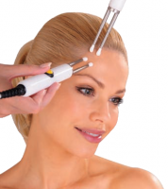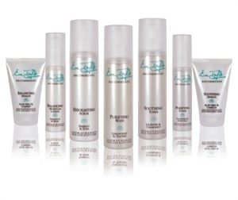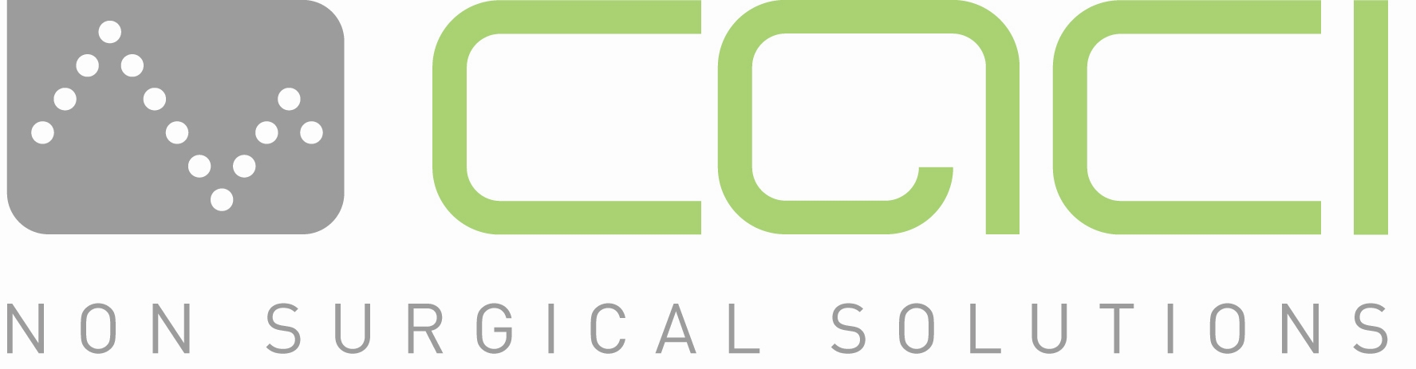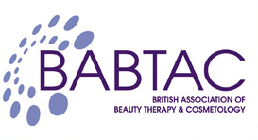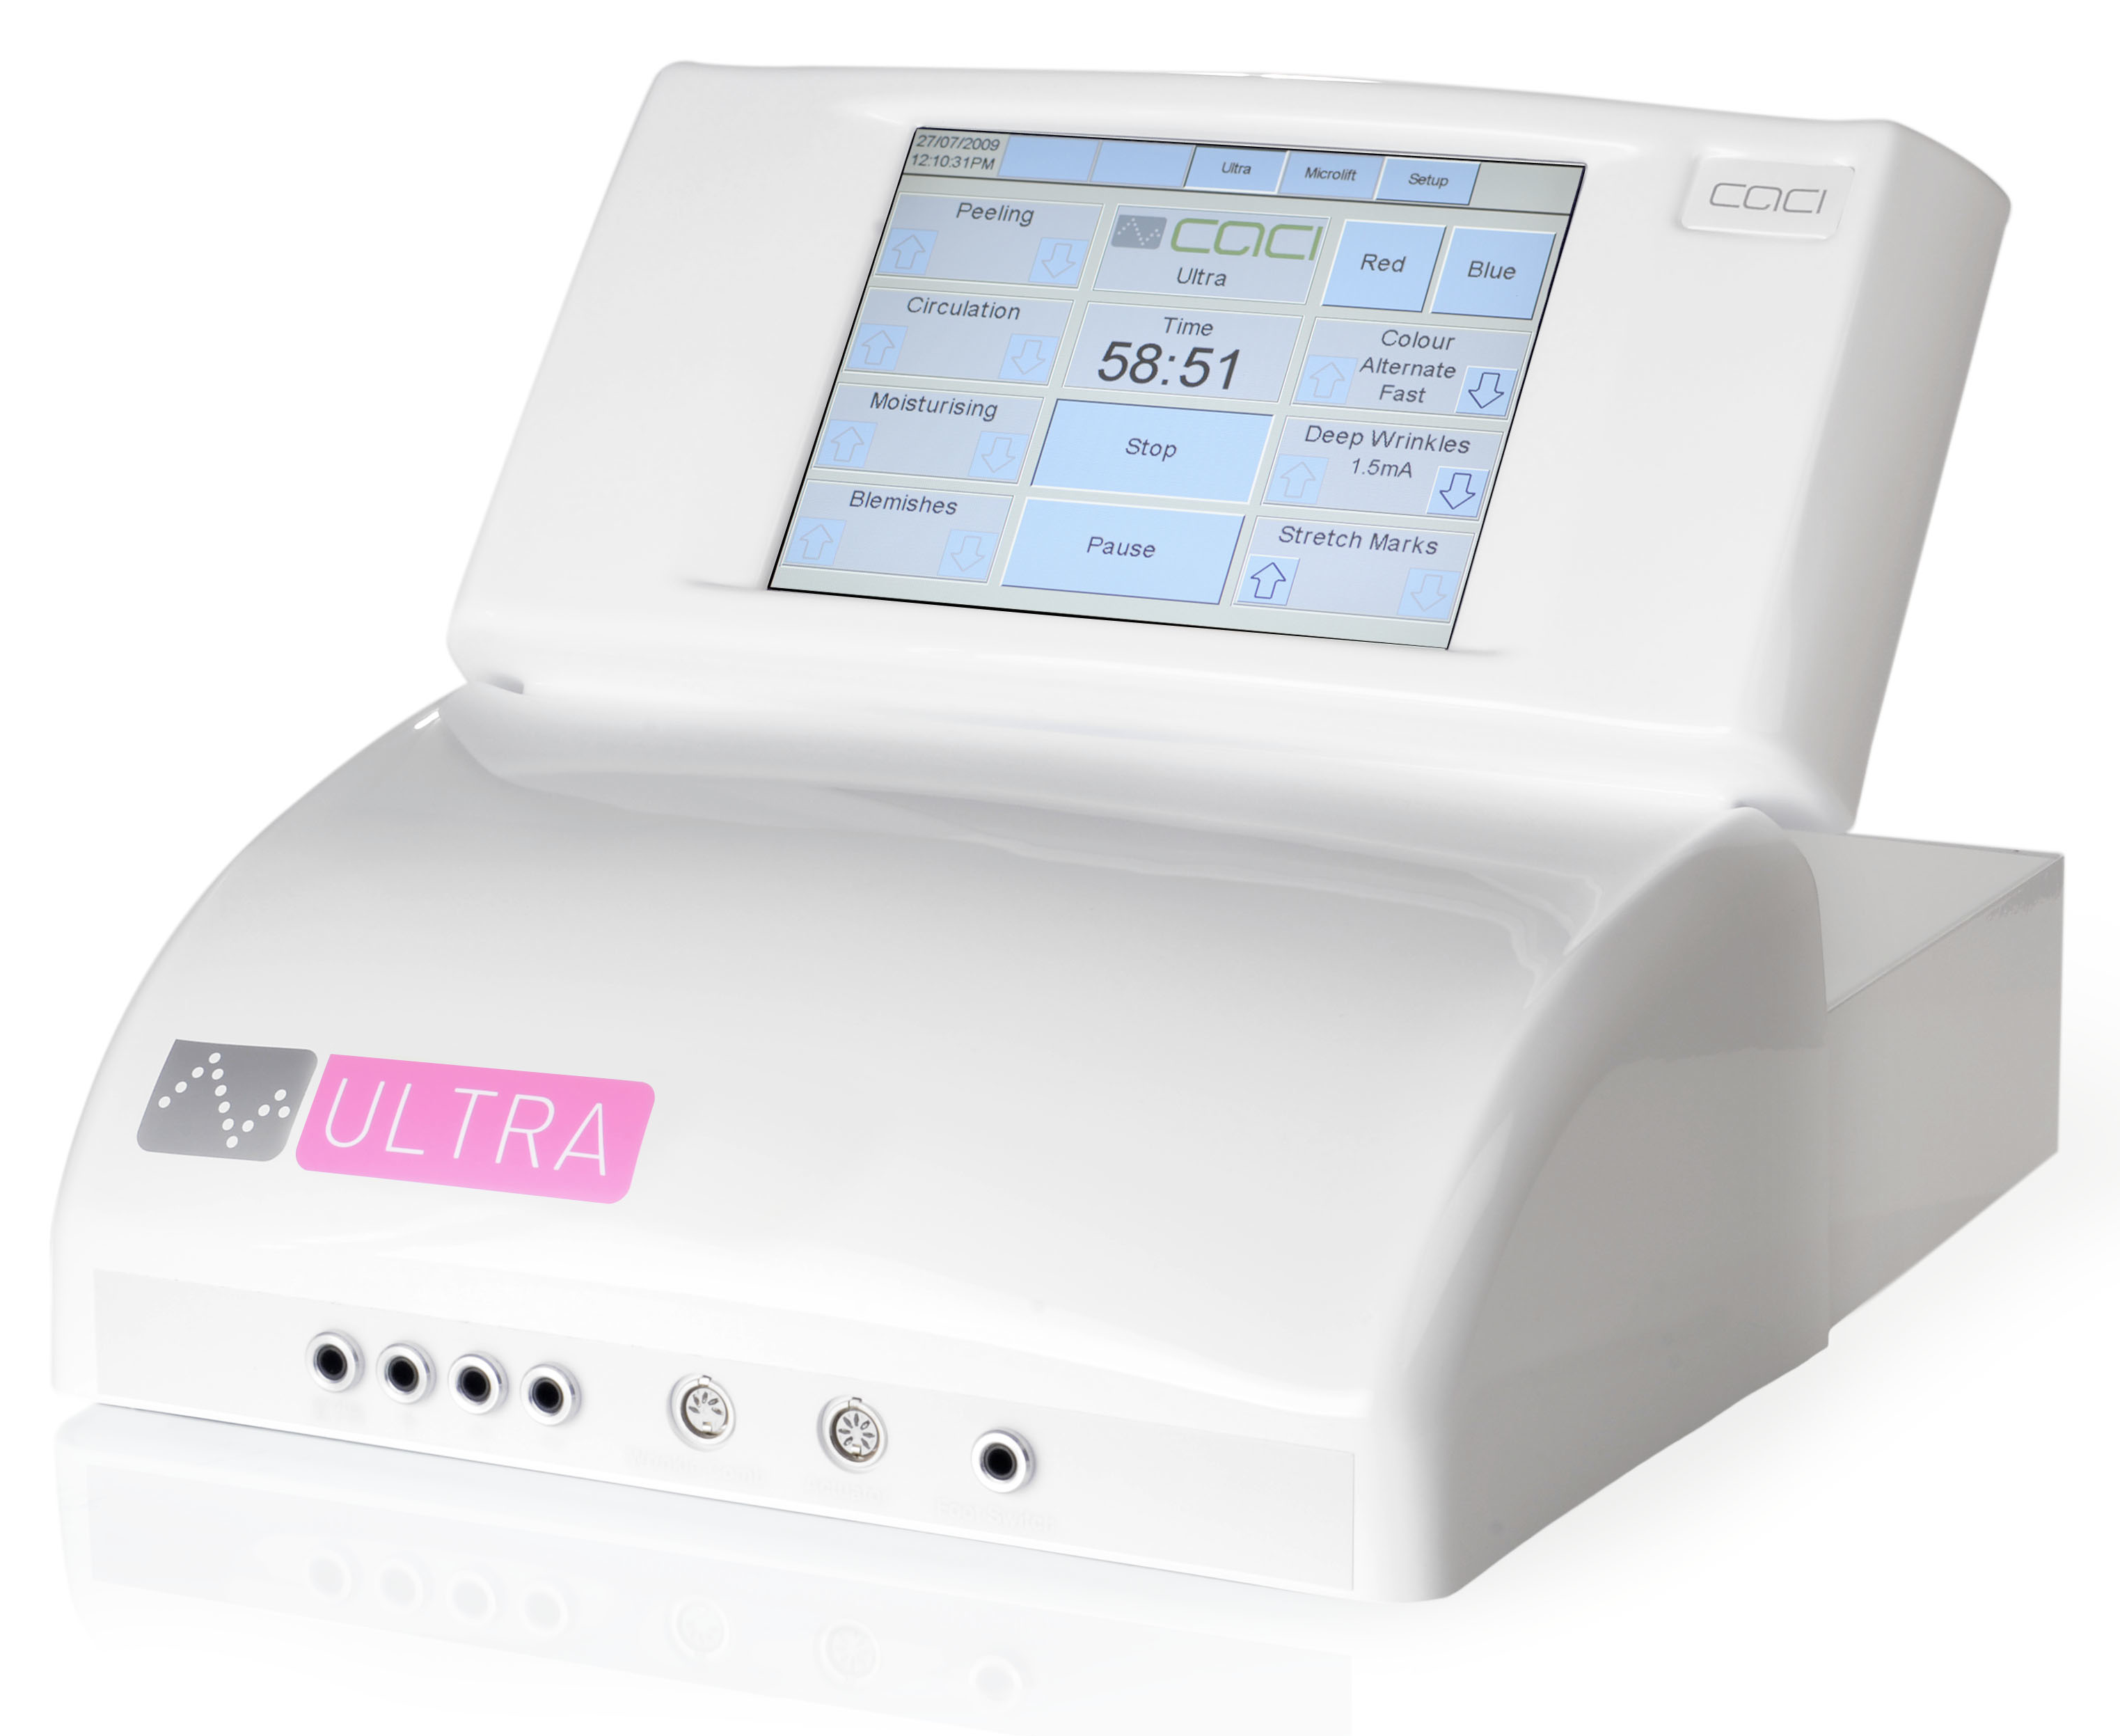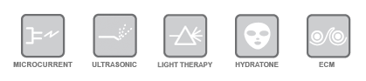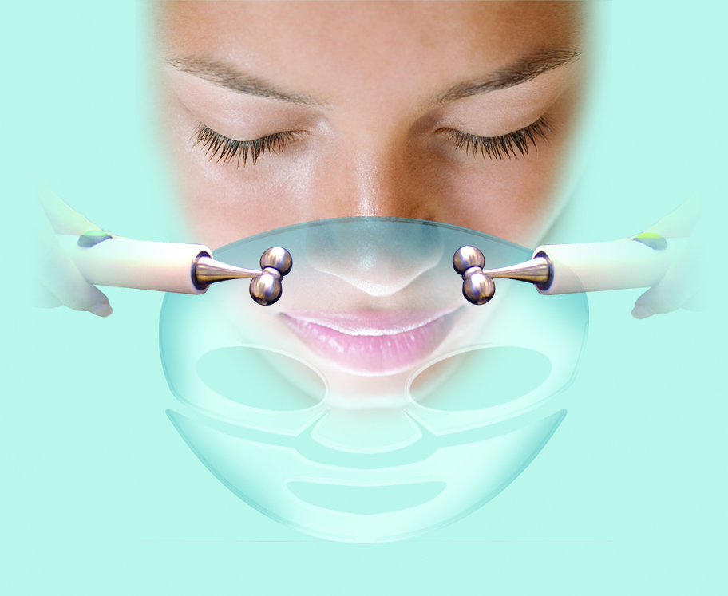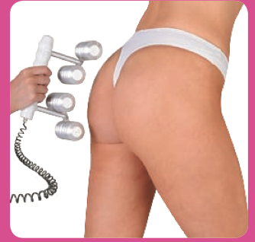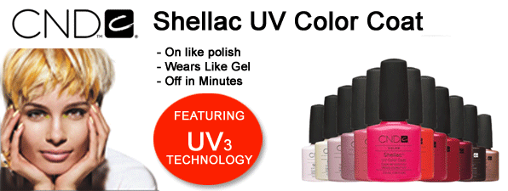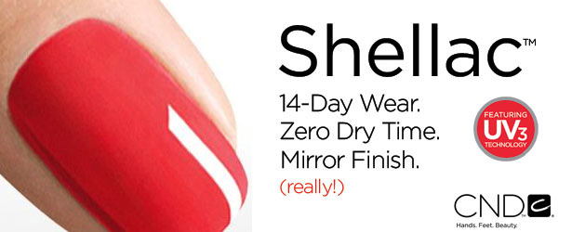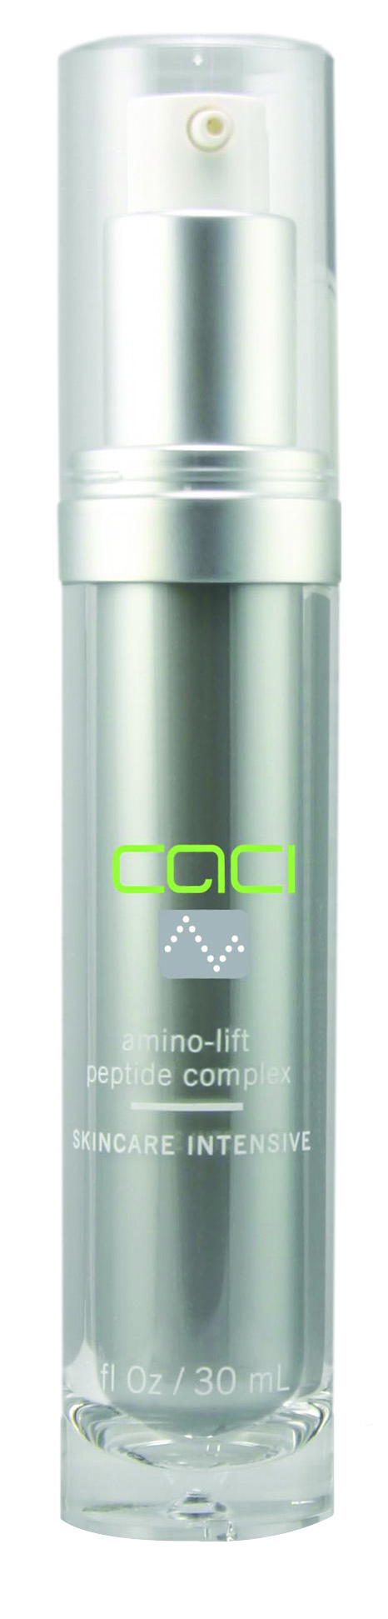

Eve Taylor has over four decades of skincare knowledge and unites the very best of plant essences with the needs of the skin. Their products are only available through salon, spa and professional therapists. At Ultra Beauty we can offer professional bespoke treatments combined with CACI Ultra. All facials will include a double cleanse, tone, ultrasonic peel, face massage finished with a mask.

**Skin brightening facial (1 hour) £30.00**

Perfect for all skin conditions, customized to your skin complaints and stress levels. This facial improves the skins radiance, appearance and texture of the skin. CACI ultrasonic peeling will be used instead of exfoliation products.

ADD ONS:

**Aromatherapy Back Massage (30 mins)** £18.00

Add exfoliation extra £5.00

A gentle back, neck and shoulder massage using Pre- Blended Aromatherapy Massage Oils to enhance the mood and relax, refresh and revive the body.

**CACI ECM BACK MASSAGE (30 mins)** £25.00

Smoothing aching limbs, stimulating circulation and Lymphatic drainage.

10% DISCOUNT ON ANY FIRST CACI FACIALS WHEN YOU BRING THIS BROCHURE.

Introduce a friend and receive 10% off your next CACI FACIAL.

07894128372

[www.ultrabeauty.co.uk](http://www.ultrabeauty.co.uk)

You can also find us on Facebook.

<https://www.facebook.com/caciultrabeauty>

For more information on CACI visit

[www.caci-international.co.uk](http://www.caci-international.co.uk)

**To book an appointment contact us**

At Ultra Beauty we value our customers and are happy to price match any other salon/spa prices for the same CACI ULTRA treatment.

Book now for your CACI ULTRA, 30 mins consultation and demo (half face only) To see the difference CACI can make.

FOR ONLY £10

Ultra Beauty is a professional home based salon situated in Laindon, Basildon.

**With convenient opening hours from**

**10am to 9pm.**

**Monday to Sunday**

Eve Taylor Aromatherapy Facials



BEAUTY

CACI Treatments

### Utilising the CACI Ultra aesthetic treatment system, we provide the most comprehensive range of non-surgical treatment options, appealing to all female clients of all ages.

**All treatments are conducted using ‘CACI’ products and some feature CACI ‘Amino-Lift Peptide Complex’**

|  |  |  |
| --- | --- | --- |
| **CACI ULTIMATE NON-SURGICAL FACELIFT (1hr 30mins)**  This comprehensive treatment is the elite in anti ageing combining four treatments in one. It incorporates the benefits of Ultrasonic Peeling, Microcurrent technology; the Wrinkle Comb Therapy (LED light therapy) and a Hydratone Mask. This treatment deep cleanses the skin, lifts and tones the facial muscles, targets deep lines and muscles and finishes with a lifting Hydratone mask.  **Recommended course of 10 treatments and maintenance every 4-6 weeks.**  **Tenth treatment is free.** | **Salon Price**  £ 75.00 | **Our Price**  **£60.00** |
| **CACI CLASSIC ANTI-AGING FACIAL (60 mins)**  This treatment gently lifts, tightens and tones the facial muscles, while soothing the appearance of fine lines and wrinkles. Skin is rehydrated while tone and texture are improved, leaving the skin with a natural glow and supple appearance.  **Recommended course of 10-15 treatments and maintenance every 4-6 weeks.**  **Add on Hydratone Mask for instant firm and hydrated skin for extra £10** | £55.00 | **£35.00** |
| **SKIN REJUVENTAING TREATMENT (45mins)**  Ultrasonic peeling is used to deeply cleanse and gently exfoliate the skin, hydrate and heal problem areas. Targets lines and wrinkles, sun damage, blemishes and acne scarring. Using wrinkle comb therapy this treatment provides a non-invasive alternative to collagen injections and derma fillers.  **Add on Hydratone Mask for instant firm and hydrated skin for extra £10** | £50.00 | **£35.00** |
| **CACI HYDRATONE FACIAL (45mins)**  Intensive skin hydration and face firming treatment. Using a mask infused with powerful hydrating properties (collagen hyaluronic acid vitamin E and C). Using rollers the face and the mask become electrically charged so that the whole face is bathed with rejuvenating energy. This treatment will replenish the facial muscles and restore tone and firmness. | £45.00 | **£35.00** |
| **CACI ULTRA EYE TREATMENT (45mins)**  Designed specifically to target the area around the eyes to reduce the signs of ageing, fatigue and puffiness. This treatment rehydrates and regenerates using the Hydratone mask, by gently ‘lifting’ the eyelids and smoothing fine lines with the wrinkle comb, the eye area will be left brighter, lifted and smoother. | £42.00 | **£30.00** |

**ULTRASONIC** peeling uses a hand piece that emits piezoelectric vibrations at 27,000 vibrations per second on the skin surface to exfoliate the skin, neutralise skin bacteria and improve blood and lymph circulation

**HYDRATONE** combines active micro currentrollers with a unique, electrically conductive silicon gel mask that has been infused with powerful moisturising properties to instantly firm and hydrate the skin.

**MICROCURRENT** technology delivers tiny electrical impulses that work in harmony with the body’s own natural bio-electrical field to soften lines and wrinkles and to re-educate facial muscles to provide a non surgical face lift.

**WRINKLE COMB THERAPY (**LED light therapy)uses precise coloured wave-lengths of light that have a bio-stimulatory and healing action on skin cells, which is effective for the treatment of acne and skin blemishes



***Ultra Beauty* is proud to offer the internationally renowned CACI treatments. These revolutionary non-surgical treatments present a pain free alternative to invasive procedures and needles.**

**Here at Ultra Beauty we conduct our treatments with the CACI ULTRA. Combining Non Surgical Facial Toning with Skin Rejuvenation. There are four different technologies incorporated in our system:**

These are available as one off treatments or can be incorporated within other treatments.

WRINKLE COMB

10mins - £10.00

Working on specific problem areas, this has a temporary plumping action, helps to repair deep lines and wrinkles. Uses Amino-Lift Peptide Complex

LED LIGHT THERAPY

15mins - £10.00

Stimulates tissue healing, provides a calming action on inflamed skin and proves to be a very effective acne treatment.

HYDRATONE MASK

Add On- £10.00

This incredible hydrating mask infuses the skin with powerful ingredients, collagen hyaluronic acid, vitamin C & E and is delicately fragrant with damask rose.

ELECTRO CELLULITE MASSAGER (ECM)

Full Legs and buttocks 30 mins –£20.00

Conductive rollers are electrically charged with microcurrent to gently knead tired shoulders, soothing aching limbs and sagging muscles. The stimulatory action of the ECM tones muscles and reduces inches by improving lymph drainage and breaking fatty deposits.

CND Shellac Nails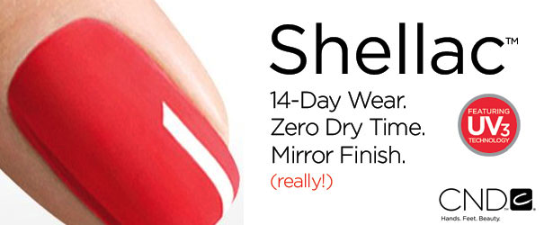

Like any quality polish application, the Shellac system features a Base Coat, Colour Coat and Top Coat. Together with a UV Lamp, they comprise the breakthrough in resilient colour that remains flawless for two weeks and removes in 10 minutes.

* 14 Day Wear
* Mirror Finish
* Zero dry time

No Nail Damage

**SHELLAC POLISH** £17.00

(includes cuticle removal file and buff)

**SHELLAC FRENCH POLISH**  £19.00

(includes cuticle removal file and buff)

**SHELLAC ROCK STAR LOOK**  £22.00

Irresistible glitters and foils

**SHELLAC REMOVAL**  £3.50

Only £1.50 if Shellac is reapplied.

ADD ON:

**EXFOLIATION AROMATHERAPY HAND MASSAGE** £4.00

CACI ULTRA ADD ONS FOR BESPOKE TREATMENTS